SECOND SUNDAY OF ADVENT Worship at 10:00 a.m. DECEMBER 6, 2015

**Words for meditation and preparation:** “He was a member of the crew on Columbus’s

ship – he kept wondering whether he would get back to his home village in time to succeed

the old shoemaker before anybody else could grab the job.” ~ Dag Hammarskjold

GATHERING MUSIC

WELCOME AND ANNOUNCEMENTS Rev. Will Burhans

SILENCE/*PASSING OF THE PEACE

PRELUDE

ADVENT CANDLE LIGHTING Ben Pulaski

Lighting of the Advent Wreath: **The Candle of Peace**

(The DuBard family lights the Peace Candle and relights the Hope Candle)

Choir: O come, thou Dayspring, come and cheer

Our spirits by thine advent here;

Disperse the gloomy clouds of night,

And death’s dark shadows put to flight.

Congregation and Choir:

***Rejoice! Rejoice! Emmanuel***

***Shall come to thee, O Israel!***

*PROCESSIONAL HYMN *There’s a Voice in the Wilderness* NCH 120

*Call to Reconciliation Kathleen Zagata

We may appear pure and blameless to others, but we know the mistakes we have made with our words, our thoughts, our actions and our inactions. God promises not only to save us from our enemies, sin and death, but from ourselves as well. Join me as we offer our confessing words to the One who will make us new once more.

Unison Prayer for Forgiveness

***You witness the sorts of lives we lead, Approaching God.***

***Asked to share the gospel of hope, we place it on our to-do list instead. Given the chance to cry out for justice for others, we fall strangely silent. Invited to pray with joy in every moment,***

***we prefer to complain about what is merely inconvenient.  
Have mercy on us, God of grace, and prepare our hearts***

***for Your forgiveness to have its way in them.***

***Fill us with Your hope so we might lighten the shadows of others.***

***Help us to join the choirs of children in singing of Your joy.***

***Transform us with that tender mercy who is our Lord and Savior, Jesus Christ.***

*Silence is kept*

*ASSURANCE OF PARDON Kathleen Zagata

God is our witness. We have spoken of our lives and been forgiven of every mistake we have made, every hurt we have caused.

***We are held in God’s heart, not only on this day,***

***but all the days of our lives. Thanks be to God, we are forgiven! Amen.***

As forgiven people, let us proclaim God’s grace in the prayer Jesus taught us

***Our Father, who art in heaven, hallowed be Thy name.***

***Thy kingdom come. Thy will be done on earth as it is in heaven***

***Give us this day our daily bread,***

***and forgive us our sins as we forgive those who sin against us.***

***And lead us not into temptation, but deliver us from evil.***

***For thine is the kingdom and the power and the glory, forever. Amen***

*Act of Praise *Gloria in Excelsis Deo* PH 116

TIME FOR THE YOUNG Ben Pulaski

*HYMN *Of the Father’s Love Begotten* PH 111

TESTIMONY Rev. Jena Roy

THE GIVING OF OUR OFFERING Rev. Will

Offertory Anthem “Bethlehem” [from *The Singing Master’s Assistant,* Boston, 1778]

                William Billings (1746 – 1800)

While shepherds watch’d their flocks by night: All seated on the ground,

The angel of the Lord came down, and glory shone around.

The angel of the Lord came down, and glory shone around…

*Advent Doxology

***Praise God from whom all blessings flow;***

***Praise Christ the Word in flesh born low.***

***Praise Holy Spirit evermore,***

***One God, Triune, whom we adore. Amen.***

*Prayer of DedicationRev. Will

SERVICE OF PRAYER (Morning Prayers, silent and spoken, and choral response)

SCRIPTURE Canticle 16: *The Song of Zechariah (Benedictus)* Elisabeth Sayre

Sung Refrain:

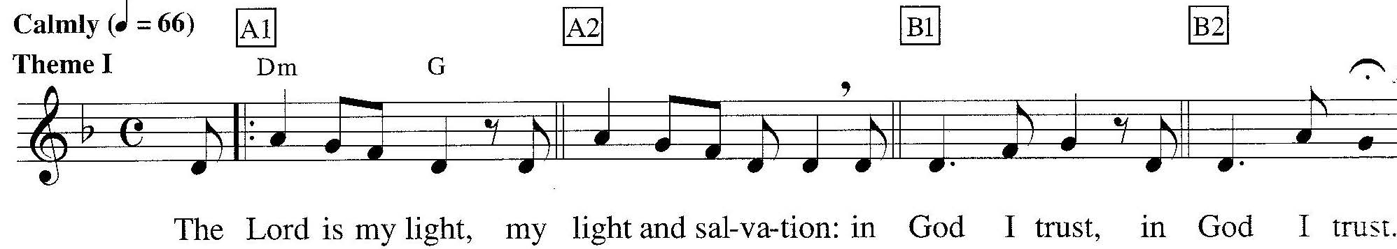

‘Blessed be the Lord God of Israel, for he has looked favourably on his people and redeemed them. He has raised up a mighty saviour for us in the house of his servant David, as he spoke through the mouth of his holy prophets from of old, that we would be saved from our enemies and from the hand of all who hate us.

**Sung Refrain**

Thus he has shown the mercy promised to our ancestors, and has remembered his holy covenant, the oath that he swore to our ancestor Abraham,to grant us that we, being rescued from the hands of our enemies, might serve him without fear, in holiness and righteousness before him all our days.

**Sung Refrain**

And you, child, will be called the prophet of the Most High; for you will go before the Lord to prepare his ways, to give knowledge of salvation to his people by the forgiveness of their sins.

**Sung Refrain**

By the tender mercy of our God, the dawn from on high will break uponus, to give light to those who sit in darkness and in the shadow of death, to guide our feet into the way of peace.’

**Sung Refrain**

Luke 3:1-6

In the fifteenth year of the reign of Emperor Tiberius, when Pontius Pilate was governor of Judea, and Herod was ruler of Galilee, and his brother Philip ruler of the region of Ituraea and Trachonitis, and Lysanias ruler of Abilene, during the high priesthood of Annas and Caiaphas, the word of God came to John son of Zechariah in the wilderness. He went into all the region around the Jordan, proclaiming a baptism of repentance for the forgiveness of sins, as it is written in the book of the words of the prophet Isaiah,

“The voice of one crying out in the wilderness: ‘Prepare the way of the Lord, make his paths straight. Every valley shall be filled, and every mountain and hill shall be made low, and the crooked shall be made straight, and the rough ways made smooth; and all flesh shall see the salvation of God.’”

MEDITATION Rev. Judith Arnold

CELEBRATION OF THE LORD’S SUPPER

Invitation and Prayer of Consecration

Sharing of the Bread and Cup (Communion today will be by intinction.

Please come forward to receive the bread and cup)

Unison Prayer of Thanksgiving

***We thank You, God, for inviting us to this table where we have known the presence of Christ and have received all Christ’s gifts.  Strengthen our faith, increase our love for one another, and help us show our love for You in how we live our lives.  AMEN***

* RECESSIONAL HYMN *On Jordan’s Bank the Baptist’s Cry* PH 115

*COMISSION & BENEDICTION

POSTLUDE

PH indicates Pilgrim Hymnal (red)

NCH indicates New Century Hymnal (black)

*Those who are able please stand

Head-sets for the hearing impaired & large print bulletins available from the deacons.

**Advent Women's Gathering...**We continue the tradition of sharing fellowship, music and spiritual reflection at the start of the Advent Journey tomorrow, December 7th at 7 pm. Please invite your spiritual friends and neighbors to join you for this special event. For additional information please contact Christine Tresselt, (617) 605-6618 cgtresselt@yahoo.com or Wendy Procops, 617 835-9953 waprocops@verizon.net

**First Congregational Church**

*“A Christ-centered, nurturing community: Growing in faith,*

*Serving in love, Welcoming all with joy.”*

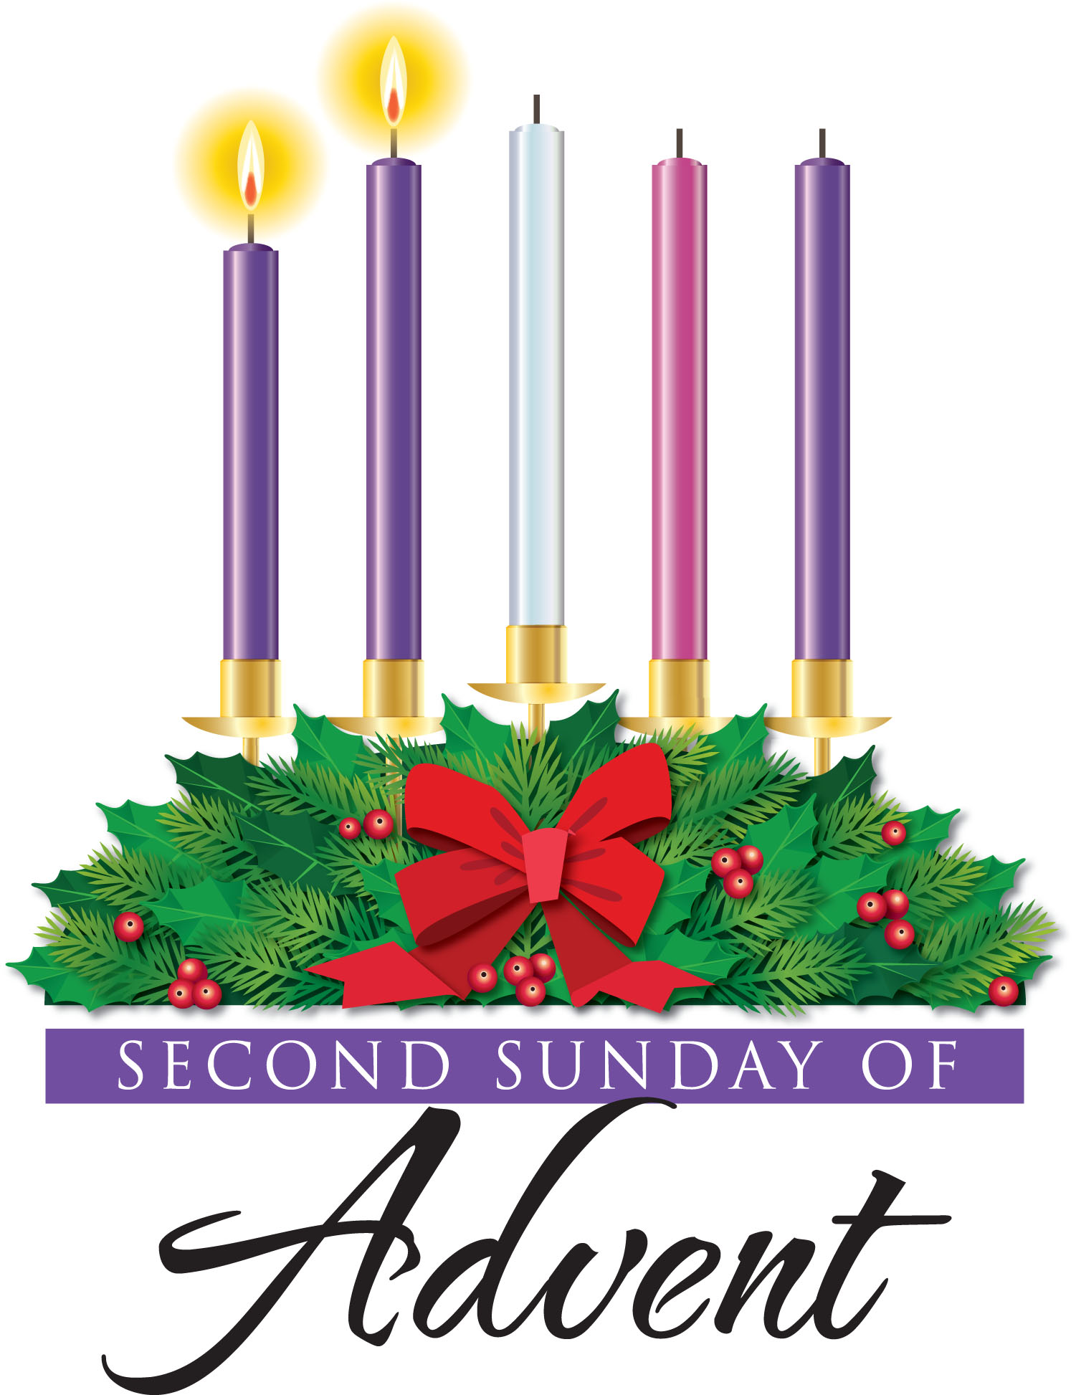

**December 6, 2015**

**SANCTUARY FLOWERS** -Today’s Chancel flowers are given to the glory of God, and in loving memory of Monica Sullivan Mahon and James J. Mahon, by the Mahon-Hayden family.

**ALL ARE WELCOME to Service of Light: A Chapel Service of Prayer, candle lighting and music** Thursday, December 18th At 7 PM in Ripley Chapel

* A time to re-balance during the rush of the holidays

* An evening to experience the quiet way Christ enters the heart when illness, divorce or a layoff disrupts life.

* A holiday service to remember those we hold dear

**For a ride, call the health ministry 781-729-9180 EXT. 16**

**Gifts with Impact:** At Sunday Coffee Hours through most of December, the Rite 13 + 6th Grade classes will be selling handmade gifts such as bookmarks, jewelry, and other accessories made with beads purchased at fair trade from Bead for Life (beadforlife.org). The students are learning about global poverty, resources, and wealth distribution through a curriculum provided by the organization. Proceeds from the items they make will be donated to a charity of their choice at the end of the school year. Please take a look and consider purchases for the family and friends on your gift list. Thanks!

**Home for the Holidays:** Parenting during the College Years Sunday December 6th 6 pm to 7:30 pm in the Tucker Room. Health Ministry is hosting a lite fare dinner and discussion for parents of college students. This Sunday the theme will include commonly held parent-student expectations regarding the college winter break. We hope both parents new to the experience and those familiar with the journey will participate.  We welcome parents from the Wider Community. "The winter break is the first extended time at home for most freshmen since they left for college in the summer,” says Karen Levin Coburn, associate vice chancellor for students at Washington University in St. Louis. “The first semester at college may have been their first glimpse of freedom. They wonder if it is possible to go home and still maintain their newfound independence.”  RSVP /Questions: Branda Wilhoite< brjwilhoite@verizon.net> Or Health Ministry Office 781-729-9180 ext 106 // Kathleenzag@gmail.com



**College Students Home for the Holidays** are invited to an informal gathering to meet our new Lead Pastor. Rev. Will Burhans will lead a *Communion Service* on *Sunday, December 20th at 6 PM at FCC.*

**Practicing Stewardship:** We celebrated stewardship on Pledge Sunday, November 8th, and we are happy to report that we are off to a great start.  To date eighty-nine pledges have been received totaling over $388,000.  If you have already pledged, thank you for your generous and joyful giving.  If you haven’t yet, then please take a moment to fill out a pledge card and mail it to the Church care of Elizabeth Cooper, Treasurer, or place it in the offering at worship today.  You can also send a confidential email with your pledge amount to first.congregational@verizon.net.  *The Financial Resources Ministry*

**Special Music Note:**William Billings was the best known American composer of psalms and hymns of the eighteenth century, sometimes called the “father of American choral music.” He was born in Boston in 1746, and started music lessons as a child, studying various psalm books with a local choirmaster. A leather tanner by trade, Billings began teaching a singing class in Stoughton, Massachusetts, which would later become the Stoughton Musical Society (America’s oldest music society and first singing school). He also organized the first church choir in America.

He wrote more than three hundred compositions, almost all of them settings of sacred texts. He was active as a singing-school master for over thirty years, and the first American “professional” composer to publish a book entirely of his own compositions. With the advent of the American Revolution, America’s first popular songs emerged from the Billings psalms. Although influenced by British psalmodists, Billings developed his own styles, which ranged from simple settings of standard hymns to long and complex anthems. Many of his compositions are beloved and sung today, including this morning’s anthem, “Bethlehem.” William Billings died in Boston on September 26, 1800. He was buried in an un-marked grave.

Speaking of the psalms, you will notice that we have replaced the Psalm with a Canticle, *The Song of Zechariah*, with a text taken directly from **Luke 1: 68-79**. A Canticle is a hymn or other non-metrical song of praise taken from biblical or holy texts other than the Psalter. In practice, canticles are sung or said in worship, and like psalms, are often found in the Liturgy of the Hours or Daily Office, liturgies that include morning prayer, lauds, matins, vespers, and evening prayer. In this morning’s Canticle (which is traditionally recited during the morning liturgies), Zechariah utters his song as prophecy and praise upon the naming of his son, John the Baptist. The first half of the canticle praises God for bringing deliverance to His people and for being true to His word -  as spoken by earlier prophets; the second half addresses John, Jesus’ forerunner, as “prophet of the Most High.” It is John who will “guide our feet in ways of peace.” We have paired this beautiful text from Luke with a simple and lovely chant from the Taizé community, “The Lord Is My Light.”

**FIRST CONGREGATIONAL CHURCH IN WINCHESTER, UCC**

21 Church Street Winchester, MA 01890 781-729-9180

An Open and Affirming Congregation

The Congregation, Ministers to The World

Rev. William Burhans, Lead Pastor

Rev. Judith B. Arnold, Associate Pastor

Ms. Kathleen Zagata, RN, MS, CS, Minister of Cong’l Health & Wellness

Ms. Jane Ring Frank, Minister of Music & Worship Arts

Ben Pulaski, Minister of Faith Formation: Children & Youth

Mr. Jeffrey Mead, Organist

Mr. Bradley Ross, Sexton

Tyler Campbell, Assistant Sexton

Sarah Marino, Office Manager

Rev. Dr. Kenneth Orth, Pastoral Counselor (Affiliate)

FCCW www.fcc-winchester.org; MA Conference www.macucc.org; Nat’l UCC www.ucc.org

**CHURCH EVENTS THIS WEEK (December 6-13)**

*Please note that City Mission Society will be in Chidley Hall all week.*

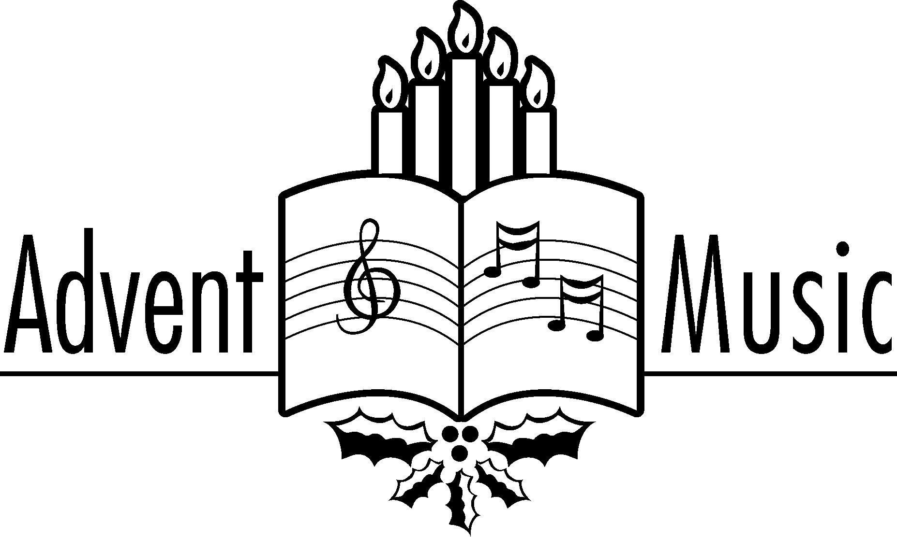

|  |
| --- |
| **015 Pledges 12/04/2015** |

**PURCHASE A HOLIDAY POINSETTIA:** You are invited to donate a chancel Christmas plant as a memorial or as a gift. Families will distribute plants to our shut-ins following the worship service on **Sunday, December 20th**

This year plants will cost $15.00.

All orders are **due by Next Sunday, 12/13/15**

I wish to purchase ______ plants, which will be

In ___memory / ___ honor (please check one) of

Donor

Please return this form with a check payable to First Congregational Church, to the church office, or place it in an offering plate in an envelope marked “Christmas plants”.

**We would appreciate your help in delivery of the plants to homebound members of our parish by coming forward and picking up a plant and a card immediately after the service on December 20th**

**SPECIAL ADVENT MUSIC at FCCW**

**JAZZ VESPERS**

Adults, families and children of all ages are invited to join us on **Saturday, December 12, 2015, 4:00 p.m.** in our Sanctuary for a short worship service, with an eclectic mix of prayer, poetry, scripture, singing and pure jazz! This Christmas themed Vespers service is sure to please and surprise, featuring a large group of guest instrumentalists, including trumpet, tenor saxophone, trombone, flute, piano, bass, drums, electric guitar and voices! Childcare is available.