THANKSGIVING SUNDAY Worship at 10 o'clock NOVEMBER 22, 2015

**Words for meditation and preparation:** "The day without doing something

good to your neighbor will not be counted in the book of eternity."

- Kuriakose Elias Chavara, 19th century Syrian Catholic saint and social reformer

GATHERING MUSIC *Nun danket alle Gott (S. 657)* J.S. Bach

WELCOME AND ANNOUNCEMENTS Rev. William Burhans

SILENCE/*PASSING OF THE PEACE Rev. Will

PRELUDE *Kremser* Neil Harmon

THE CALL TO WORSHIP (from A *Wee Book of Worship*) Ben Pulaski

From the rising of the sun till its setting in the west,

***God’s holy name be praised.***

On the lips of children, by babies at the breast,

***God’s holy name be praised.***

In the visions of the old and the dreaming of the young,

***God’s holy name be praised.***

In the banquet hall of heaven and the forgotten corners of our hearts,

***God’s holy name be praised.***

Let all that has life and breath praise the Lord.

***We praise the Lord, Amen!***

*PROCESSIONAL HYMN *Come, Ye Thankful People, Come*

red-covered Pilgrim Hymnal #461

*GATHERING Prayer AND LORD”S PRAYER Rev. Judy Arnold

(adapted from prayer by Ted Loder in "Guerilla’s of Grace")

***On this day, O God, all is praise and thanks for all our days.***

***We breathe and it is your breath that fills us.***

***We look and it is your light by which we see.***

***We move and it is your energy moving in us.***

***We think and the thoughts are but sparks from the fire of your truth…***

***O Glorious One we thank you for the abundance of this world.***

***Forgive us for our actions that arise out of a sense of scarcity and fear***

***and inspire in us good works that increase your blessings upon this earth.***

***In Jesus' name through whom your kingdom is spreading…***

***Our Father, who art in heaven, hallowed be Thy name. Thy kingdom come, Thy will be done, on earth as it is in heaven. Give us this day our daily bread, and forgive us our sins as we forgive those who sin against us. Lead us not into temptation, but deliver us from evil. For Thine is the kingdom and the power and the glory forever. Amen.***

*Act of Praise *The Gloria Patri*  PH 513

(Please use words that are most meaningful to you)

***Glory be to the Creator and to the Christ and to the Holy Ghost;***

***As it was in the beginning, is now and ever shall be;***

***World without end, amen, amen.***

ANTHEM  *Grateful: A Love Song to the World*

Lyrics and Video by Nimo Patel and Daniel Nahmod

Stepping Stones Choir, Cindy Wankowicz, Conductor

TIME FOR THE YOUNG Ben Pulaski

SERVICE OF PRAYER Rev. Judy

Morning Prayers, silent and spoken

ANTHEM O Sing to the Lord [2005] Andrew Carter (b. 1939)

                                                                                             Psalm 98:1, 5-8 (4-7)

O sing, O sing to the Lord a new song, for he has done marvelous things.

Show yourselves joyful to the Lord, all ye lands; sing, rejoice, and give thanks.

Praise the Lord, praise him on the harp.

Sing to the harp with a psalm of thanksgiving.

With trumpets and with shawms show yourselves joyful before the Lord our King.

Let the sea make a noise, and all that therein is,

and the round world and they that dwell therein.

O sing, O sing to the Lord a new song, for he has done marvelous things.

SCRIPTURE Psalm 138, 1-2, 6-8 Rev. Jena Roy

**SUNG REFRAIN**

***Great is the glory of God*.**

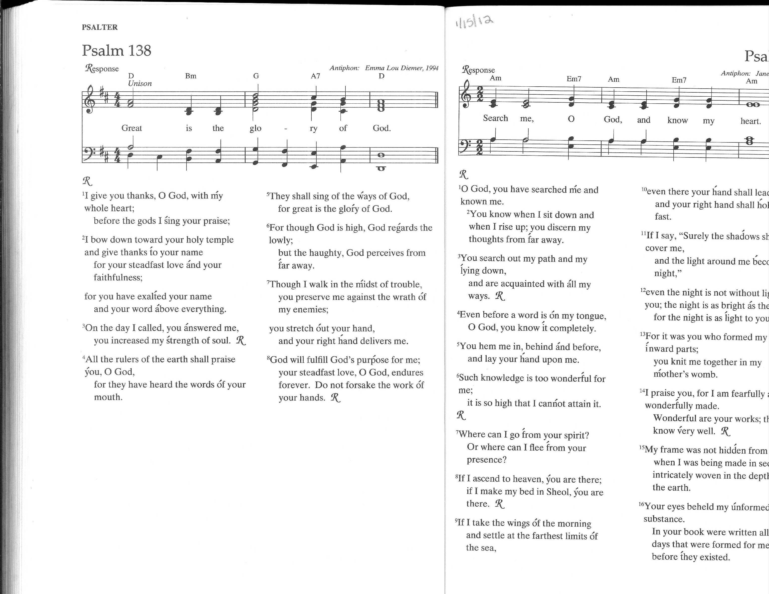

I give you thanks, O God, with my whole heart; before the gods I sing your praise;

**SUNG REFRAIN**

I bow down toward your holy temple and give thanks to your name for your steadfast love and your faithfulness; for you have exalted your name and your word above everything.

**SUNG REFRAIN**

For though God is high, God regards the lowly; but the haughty, God perceives from far away.

**SUNG REFRAIN**

Though I walk in the midst of trouble, you preserve me against the wrath of my enemies;

you stretch out your hand, and your right hand delivers me.

**SUNG REFRAIN**

God will fulfill God's purpose for me; your steadfast love, O God, endures forever.

 Do not forsake the work of your hands.

**SUNG REFRAIN**

Romans 12: 9-21

Let love be genuine; hate what is evil, hold fast to what is good; love one another with mutual affection; outdo one another in showing honor. Do not lag in zeal, be ardent in spirit, serve the Lord. Rejoice in hope, be patient in suffering, persevere in prayer. Contribute to the needs of the saints; extend hospitality to strangers.

Bless those who persecute you; bless and do not curse them. Rejoice with those who rejoice, weep with those who weep. Live in harmony with one another; do not be haughty, but associate with the lowly; do not claim to be wiser than you are. Do not repay anyone evil for evil, but take thought for what is noble in the sight of all. If it is possible, so far as it depends on you, live peaceably with all. Beloved, never avenge yourselves, but leave room for the wrath of God; for it is written, “Vengeance is mine, I will repay, says the Lord.”No, “if your enemies are hungry, feed them; if they are thirsty, give them something to drink; for by doing this you will heap burning coals on their heads.” Do not be overcome by evil, but overcome evil with good.

SERMON “A Counter Intelligence” Rev. Will

THE OFFERING Rev. Will

Offertory *Spiegel im Spiegel* (Mirror in the Mirror), [1978] Arvo Pärt (b. 1935)

Robert Skinner, flute      Jane Ring Frank, piano

Blessing Rev. Judy

RECESSIONAL HYMN *Now Thank We All Our God*

black-covered New Century Hymnal #419

*COMMISSION AND BENEDICTION (remain standing please) Rev. Will

POSTLUDE *Nun danket* Harmon

**Please join us in Chidley Hall for our annual Stone Soup Lunch**

PH indicates Pilgrim Hymnal (red) NCH indicates New Century Hymnal (black)

*Those who are able please stand

Head-sets for the hearing impaired & large print bulletins available from the deacons.



**Free Ticket: Use the Free Visitor Ticket enclosed in today’s bulletin to invite a friend to our annual Tree Lighting Community Supper, December 3, 5pm-7pm in Chidley Hall. These tickets are our way of welcoming in people from outside our congregation. Ticket holders and their families join us for free as our guests**.

**First Congregational Church**

*“A Christ-centered, nurturing community: Growing in faith,*

*Serving in love, Welcoming all with joy.”*

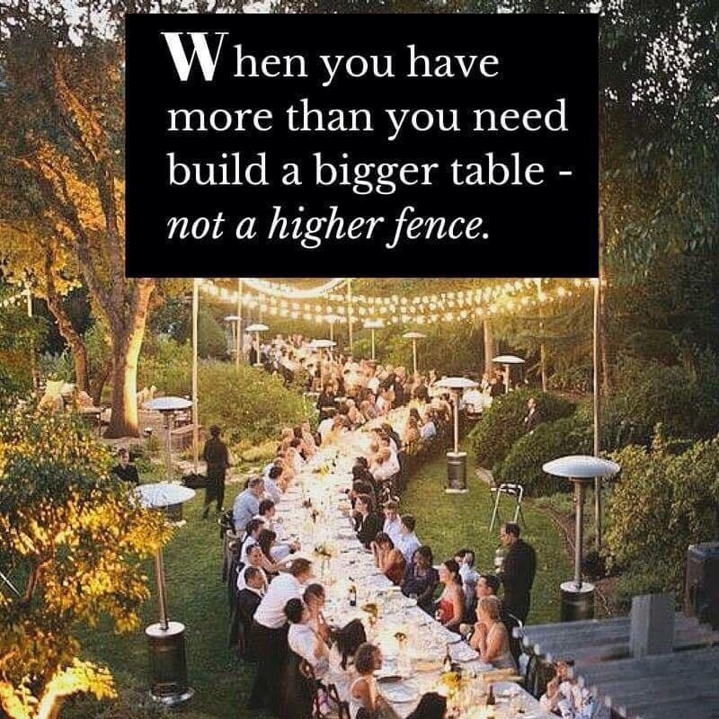

November 22, 2015

**CHURCH EVENTS THIS WEEK (NOVEMBER 22 - 29 )**



**THE SANCTUARY FLOWERS** this morning are given to the Glory of God and in loving memory of Courtney Crandall, given by his family.

**Gifts with Impact:** At Sunday Coffee Hours through most of December, the Rite 13 + 6th Grade classes will be selling handmade gifts such as bookmarks, jewelry, and other accessories made with beads purchased at fair trade from Bead for Life (beadforlife.org). The students are learning about global poverty, resources, and wealth distribution through a curriculum provided by the organization. Proceeds from the items they make will be donated to a charity of their choice at the end of the school year. Please take a look and consider purchases for the family and friends on your gift list. Thanks!

**Ruth Group** **Ruth Group is meeting** **tonight, Sunday, November 22** **at** **7:00 p.m.**, at the home of Martha (Mike) Redding, 154 High St., Apt. 40 2, Medford, MA 01255.  Mike and Laurie Roby will host a discussion of Being Mortal by Atul Gawande.  All women are welcome.  If you need a ride, please email Laurie at lauriefroby@gmail.com or call her at 781-643-1345. Mike can be reached at 781-391-7873.

**An invitation to the Leadership Team meeting!**

**November 22nd at 11:30 am in the Henry Room.**

The Leadership Team, the group that has strategic decision-making responsibility in our church, is having its November meeting on November 22nd.

The first part of the meeting is open to all-comers, so that there is opportunity for anyone within our congregation, including representatives of sustaining and living ministries, to bring items to the Leadership Team for presentation or discussion, or just to come and be a part of our getting together. Please feel invited to our November meeting and let me know if there is something that you would like to discuss or present.  We can work to determine whether the topic is appropriate for LT strategic decision making and discernment.

**FIRST CONGREGATIONAL CHURCH IN WINCHESTER, UCC**

21 Church Street Winchester, MA 01890 781-729-9180

An Open and Affirming Congregation

The Congregation, Ministers to The World

Rev. William Burhans, Lead Pastor

Rev. Judith B. Arnold, Associate Pastor

Ms. Kathleen Zagata, RN, MS, CS, Minister of Cong’l Health & Wellness

Ms. Jane Ring Frank, Minister of Music & Worship Arts

Ben Pulaski, Minister of Faith Formation: Children & Youth

Mr. Jeffrey Mead, Organist

Mr. Bradley Ross, Sexton

Tyler Campbell, Sexton

Sarah Marino, Office Manager

Rev. Dr. Kenneth Orth, Pastoral Counselor (Affiliate)

FCCW www.fcc-winchester.org; MA Conference www.macucc.org; Nat’l UCC www.ucc.org

**Invitation to the Service of Light**

**Thursday December 17th at 7 pm**

**Ripley Chapel**

**First Congregational Church - Winchester, MA**

**Hosted by the Health Ministry Commission**

**Ring, the bell that still can ring**

The Ripley Chapel Service of Light is a way our church family remembers those who experience a loss of joy this holiday season. Blessed are those who are lonely, grieve the loss of a loved one, experience a health crisis or financial insecurity. We welcome you.

**Forget the perfect offering**

The Service of light was first held in 2001, a response to our collective mourning in the wake of 9/11. Since then, church members, neighbors and friends come for a given year or return yearly to find a still point in the mist of the seasonal rush or to remember. This year it may be a personal challenge, family grief or community tragedy that calls you forth to light a candle.

**There is a crack, a crack in everything**

In this season of the longest night when the heart is heavy with fear, emotional pain, broken dreams, change and transitions, connecting with the season’s message may be difficult. Yet, on reflection we are reminded that struggle and bewilderment were not foreign to Joseph and Mary on their journey. Jesus himself was no stranger to being an outsider, displaced, a refugee.

**That’s how the light gets in.\***

Designed to move from darkness to hope, the music, readings and candle lighting in the warmth of community open us to God’s quiet presence. We pray that our lives will be graced with the true gifts of the season, a peace which surpasses all understanding; Love Divine and encouragement that sustain though the longest night.

**Open to the Wider Community**

*Kathleen Zagata*, Health Minister

Rides available upon request by 12/15

Call: 781-729-9180 ext 106

*Quote by Leonard Cohen

**You Are Cordially Invited to**



**Participate in**

**City Mission 2015 Christmas Shop**

City Mission’s **Christmas Shop** once again celebrates its partnership with local churches, businesses and individuals who give gifts of the heart to honor the birth of Jesus Christ and to help families and children in need. The City Mission Christmas Shop brings the joy of giving and receiving to many people in the Greater Boston Metropolitan area annually. In 2014 over 3,600 adults and children benefited, thanks to the generosity of hundreds of members of more than 40 local churches, groups and organizations. **In 2015 we expect the need to be even greater.**

**Gift Suggestions*:******We accept only NEW items. These are listed by priority.***

* **Winter coats, sweaters and sweatshirts (large sizes especially)**
* **Hats, mittens, gloves and scarves**
* **Socks and underwear**
* **Blankets and backpacks**
* **Toys, games, and books for all ages**
* **Gift cards from Target, Marshalls, Walgreens, CVS, Kohl’s, Walmart, Stop and Shop, Shaw’s and other merchants**

**City Mission Identifies Families in Need:**

Throughout the fall, City Mission staff identifies children and families in need within City Mission programs and partnerships. Together we assess the needs of the Boston community and identify persons in need of holiday assistance.

**Partner Churches Donate Needed Items:**

**NEW** clothing, toys and other items including store gift cards come from over 40 churches, groups and organizations. They are purchased or hand-made by individuals and families who believe that Christmas is an important time to share hope, joy and love with others.

**Volunteers Sort and Pack Gifts for Their Neighbors:**

More than 10,000 items are delivered to **First Congregational Church in Winchester**. They are sorted and repacked for distribution by volunteers from church youth groups, women’s fellowships and other groups, including families who want to help.