Rev Will Burhans preached a sermon "Considering the Salt of the Earth” on Feb 5, 2017 in which he referenced both the book Hillbilly Elegy and a Harvard Business Review article “What So Many People Don’t Get About the U.S. Working Class”. This is an excerpt from his sermon that provides some compelling context for the Hillbilly book and the HBR article:

“You are the salt of the earth.” Jesus is talking to his disciples but that phrase from scripture has become a familiar idiom, so that when we hear “salt of the earth”… we think usually of an older working class man or woman, a farmer maybe, definitely a laborer of some sort, who leads a simple life with a certain honesty and goodness in their simplicity. But as I heard the phrase in the scripture this week in light of our current political situation, one thing nudged at me and I tried to ignore it but it kept coming up and that was that it was those salt of the earth type people – at least a lot of them - who put Donald Trump in office.”

“President Trump’s inauguration speech sounded to many of us like a bizarre dystopian picture of an America in shambles and on the brink of chaos. But while we might have been shocked by such a picture, there were many in rural middle America who were nodding their heads in full agreement, glad that someone was finally naming the truth. Statistics show that rural middle to lower class blue-collar America over the last 30 years has been dealing with a formidable increase of joblessness, divorce, mental illness, heroin and prescription opioid abuse, and suicide – I mean, some serious suffering. Over these years, secure jobs that provide for a decent middle class life have been drained for various reasons from the white working class and now go to the college educated. And when we remember that in our country only 30% of Americans 25 and older are college educated, I for one am brought up short and realize suddenly how someone who knew how to speak their language and effectively offered the promise of middle class security back to them could be elected.”

“There is a lot being written about it all that we working class professionals should read to understand the others. Hillbilly Elegy: A Memoir of Family and Culture in Crisis is the NY Times bestseller that’s being read right now and an article that I found so enlightening and that increased my compassion quotient quite a bit for the salt of the earth Trump voter is by Joan Williams in the Harvard Business Review called “What so Many People Don’t Get About the U.S. Working Class”.”

I am disturbed by our president’s immigration ban and do not want to dismiss such action that flies in the face of obvious gospel values and I have been so grateful and heartened that so many in our country have been standing against it. But the challenge I am hearing from this scripture this morning is the need for those of us middle to upper class educated professionals to not get too entrenched in our class culture that we write off the others in our country as racist, small minded, xenophobes, because that is not who they are but our brothers and sisters who have been suffering and fearful and up til now – til President Trump captured their imaginations for some reason – have felt marginalized, oppressed, and unheard. ..."

You can find a podcast of Rev Will’s full sermon on the FCCW website at: http://www.fcc-winchester.com/worship-music/sermon-podcasts/ Scroll down to Feb 5, 2017 to find the full sermon titled "Considering the Salt of the Earth”.

The Harvard Business Review article follows:

What So Many People Don’t Get About the Working Class
Joan C. Williams
NOVEMBER 10, 2016

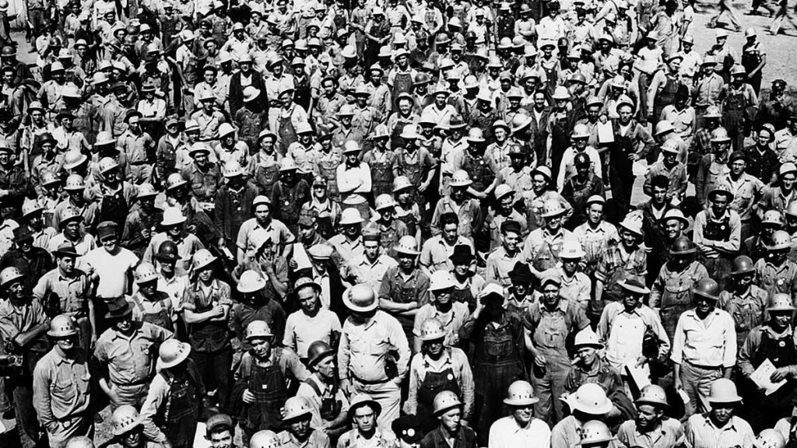
My father-in-law grew up eating blood soup. He hated it, whether because of the taste or the humiliation, I never knew. His alcoholic father regularly drank up the family wage, and the family was often short on food money. They were evicted from apartment after apartment.
He dropped out of school in eighth grade to help support the family. Eventually he got a good, steady job he truly hated, as an inspector in a factory that made those machines that measure humidity levels in museums. He tried to open several businesses on the side but none worked, so he kept that job for 38 years. He rose from poverty to a middle-class life: the car, the house, two kids in Catholic school, the wife who worked only part-time. He worked incessantly. He had two jobs in addition to his full-time position, one doing yard work for a local magnate and another hauling trash to the dump.
Throughout the 1950s and 1960s, he read The Wall Street Journal and voted Republican. He was a man before his time: a blue-collar white man who thought the union was a bunch of jokers who took your money and never gave you anything in return. Starting in 1970, many blue-collar whites followed his example. This week, their candidate won the presidency.
For months, the only thing that’s surprised me about Donald Trump is my friends’ astonishment at his success. What’s driving it is the class culture gap.
One little-known element of that gap is that the white working class (WWC) resents professionals but admires the rich. Class migrants (white-collar professionals born to blue-collar families) report that “professional people were generally suspect” and that managers are college kids “who don’t know shit about how to do anything but are full of ideas about how I have to do my job,” said Alfred Lubrano in Limbo. Barbara Ehrenreich recalled in 1990 that her blue-collar dad “could not say the word doctor without the virtual prefix quack. Lawyers were shysters…and professors were without exception phonies.” Annette Lareau found tremendous resentment against teachers, who were perceived as condescending and unhelpful.
Michèle Lamont, in The Dignity of Working Men, also found resentment of professionals — but not of the rich. “[I] can’t knock anyone for succeeding,” a laborer told her. “There’s a lot of people out there who are wealthy and I’m sure they worked darned hard for every cent they have,” chimed in a receiving clerk. Why the difference? For one thing, most blue-collar workers have little direct contact with the rich outside of Lifestyles of the Rich and Famous. But professionals order them around every day. The dream is not to become upper-middle-class, with its different food, family, and friendship patterns; the dream is to live in your own class milieu, where you feel comfortable — just with more money. “The main thing is to be independent and give your own orders and not have to take them from anybody else,” a machine operator told Lamont. Owning one’s own business — that’s the goal. That’s another part of Trump’s appeal.
Hillary Clinton, by contrast, epitomizes the dorky arrogance and smugness of the professional elite. The dorkiness: the pantsuits. The arrogance: the email server. The smugness: the basket of deplorables. Worse, her mere presence rubs it in that even women from her class can treat working-class men with disrespect. Look at how she condescends to Trump as unfit to hold the office of the presidency and dismisses his supporters as racist, sexist, homophobic, or xenophobic.
Trump’s blunt talk taps into another blue-collar value: straight talk. “Directness is a working-class norm,” notes Lubrano. As one blue-collar guy told him, “If you have a problem with me, come talk to me. If you have a way you want something done, come talk to me. I don’t like people who play these two-faced games.” Straight talk is seen as requiring manly courage, not being “a total wuss and a wimp,” an electronics technician told Lamont. Of course Trump appeals. Clinton’s clunky admission that she talks one way in public and another in private? Further proof she’s a two-faced phony.
Manly dignity is a big deal for working-class men, and they’re not feeling that they have it. Trump promises a world free of political correctness and a return to an earlier era, when men were men and women knew their place. It’s comfort food for high-school-educated guys who could have been my father-in-law if they’d been born 30 years earlier. Today they feel like losers — or did until they met Trump.
Manly dignity is a big deal for most men. So is breadwinner status: Many still measure masculinity by the size of a paycheck. White working-class men’s wages hit the skids in the 1970s and took another body blow during the Great Recession. Look, I wish manliness worked differently. But most men, like most women, seek to fulfill the ideals they’ve grown up with. For many blue-collar men, all they’re asking for is basic human dignity (male varietal). Trump promises to deliver it.
The Democrats’ solution? Last week the New York Times published an article advising men with high-school educations to take pink-collar jobs. Talk about insensitivity. Elite men, you will notice, are not flooding into traditionally feminine work. To recommend that for WWC men just fuels class anger.
Isn’t what happened to Clinton unfair? Of course it is. It is unfair that she wasn’t a plausible candidate until she was so overqualified she was suddenly unqualified due to past mistakes. It is unfair that Clinton is called a “nasty woman” while Trump is seen as a real man. It’s unfair that Clinton only did so well in the first debate because she wrapped her candidacy in a shimmy of femininity. When she returned to attack mode, it was the right thing for a presidential candidate to do but the wrong thing for a woman to do. The election shows that sexism retains a deeper hold than most imagined. But women don’t stand together: WWC women voted for Trump over Clinton by a whopping 28-point margin — 62% to 34%. If they’d split 50-50, she would have won.
Class trumps gender, and it’s driving American politics. Policy makers of both parties — but particularly Democrats if they are to regain their majorities — need to remember five major points.

Understand That Working Class Means Middle Class, Not Poor
The terminology here can be confusing. When progressives talk about the working class, typically they mean the poor. But the poor, in the bottom 30% of American families, are very different from Americans who are literally in the middle: the middle 50% of families whose median income was $64,000 in 2008. That is the true “middle class,” and they call themselves either “middle class” or “working class.”
“The thing that really gets me is that Democrats try to offer policies (paid sick leave! minimum wage!) that would help the working class,” a friend just wrote me. A few days’ paid leave ain’t gonna support a family. Neither is minimum wage. WWC men aren’t interested in working at McDonald’s for $15 per hour instead of $9.50. What they want is what my father-in-law had: steady, stable, full-time jobs that deliver a solid middle-class life to the 75% of Americans who don’t have a college degree. Trump promises that. I doubt he’ll deliver, but at least he understands what they need.

Understand Working-Class Resentment of the Poor
Remember when President Obama sold Obamacare by pointing out that it delivered health care to 20 million people? Just another program that taxed the middle class to help the poor, said the WWC, and in some cases that’s proved true: The poor got health insurance while some Americans just a notch richer saw their premiums rise.
Progressives have lavished attention on the poor for over a century. That (combined with other factors) led to social programs targeting them. Means-tested programs that help the poor but exclude the middle may keep costs and tax rates lower, but they are a recipe for class conflict. Example: 28.3% of poor families receive child-care subsidies, which are largely nonexistent for the middle class. So my sister-in-law worked full-time for Head Start, providing free child care for poor women while earning so little that she almost couldn’t pay for her own. She resented this, especially the fact that some of the kids’ moms did not work. One arrived late one day to pick up her child, carrying shopping bags from Macy’s. My sister-in-law was livid.
J.D. Vance’s much-heralded Hillbilly Elegy captures this resentment. Hard-living families like that of Vance’s mother live alongside settled families like that of his biological father. While the hard-living succumb to despair, drugs, or alcohol, settled families keep to the straight and narrow, like my parents-in-law, who owned their home and sent both sons to college. To accomplish that, they lived a life of rigorous thrift and self-discipline. Vance’s book passes harsh judgment on his hard-living relatives, which is not uncommon among settled families who kept their nose clean through sheer force of will. This is a second source of resentment against the poor.
Other books that get at this are Hard Living on Clay Street (1972) and Working-Class Heroes (2003).

Understand How Class Divisions Have Translated into Geography
The best advice I’ve seen so far for Democrats is the recommendation that hipsters move to Iowa. Class conflict now closely tracks the urban-rural divide. In the huge red plains between the thin blue coasts, shockingly high numbers of working-class men are unemployed or on disability, fueling a wave of despair deaths in the form of the opioid epidemic.
Vast rural areas are withering away, leaving trails of pain. When did you hear any American politician talk about that? Never.
Jennifer Sherman’s Those Who Work, Those Who Don’t (2009) covers this well.

If You Want to Connect with White Working-Class Voters, Place Economics at the Center
“The white working class is just so stupid. Don’t they realize Republicans just use them every four years, and then screw them?” I have heard some version of this over and over again, and it’s actually a sentiment the WWC agrees with, which is why they rejected the Republican establishment this year. But to them, the Democrats are no better.
Both parties have supported free-trade deals because of the net positive GDP gains, overlooking the blue-collar workers who lost work as jobs left for Mexico or Vietnam. These are precisely the voters in the crucial swing states of Ohio, Michigan, and Pennsylvania that Democrats have so long ignored. Excuse me. Who’s stupid?
One key message is that trade deals are far more expensive than we’ve treated them, because sustained job development and training programs need to be counted as part of their costs.
At a deeper level, both parties need an economic program that can deliver middle-class jobs. Republicans have one: Unleash American business. Democrats? They remain obsessed with cultural issues. I fully understand why transgender bathrooms are important, but I also understand why progressives’ obsession with prioritizing cultural issues infuriates many Americans whose chief concerns are economic.
Back when blue-collar voters used to be solidly Democratic (1930–1970), good jobs were at the core of the progressive agenda. A modern industrial policy would follow Germany’s path. (Want really good scissors? Buy German.) Massive funding is needed for community college programs linked with local businesses to train workers for well-paying new economy jobs. Clinton mentioned this approach, along with 600,000 other policy suggestions. She did not stress it.

Avoid the Temptation to Write Off Blue-Collar Resentment as Racism
Economic resentment has fueled racial anxiety that, in some Trump supporters (and Trump himself), bleeds into open racism. But to write off WWC anger as nothing more than racism is intellectual comfort food, and it is dangerous.
National debates about policing are fueling class tensions today in precisely the same way they did in the 1970s, when college kids derided policemen as “pigs.” This is a recipe for class conflict. Being in the police is one of the few good jobs open to Americans without a college education. Police get solid wages, great benefits, and a respected place in their communities. For elites to write them off as racists is a telling example of how, although race- and sex-based insults are no longer acceptable in polite society, class-based insults still are.
I do not defend police who kill citizens for selling cigarettes. But the current demonization of the police underestimates the difficulty of ending police violence against communities of color. Police need to make split-second decisions in life-threatening situations. I don’t. If I had to, I might make some poor decisions too.
Saying this is so unpopular that I risk making myself a pariah among my friends on the left coast. But the biggest risk today for me and other Americans is continued class cluelessness. If we don’t take steps to bridge the class culture gap, when Trump proves unable to bring steel back to Youngstown, Ohio, the consequences could turn dangerous.
In 2010, while on a book tour for Reshaping the Work-Family Debate, I gave a talk about all of this at the Harvard Kennedy School. The woman who ran the speaker series, a major Democratic operative, liked my talk. “You are saying exactly what the Democrats need to hear,” she mused, “and they’ll never listen.” I hope now they will.
***

Joan C. Williams is Distinguished Professor of Law and Founding Director of the Center of WorkLife Law at the University of California, Hastings College of the Law. Her newest book is the forthcoming White Working Class.

